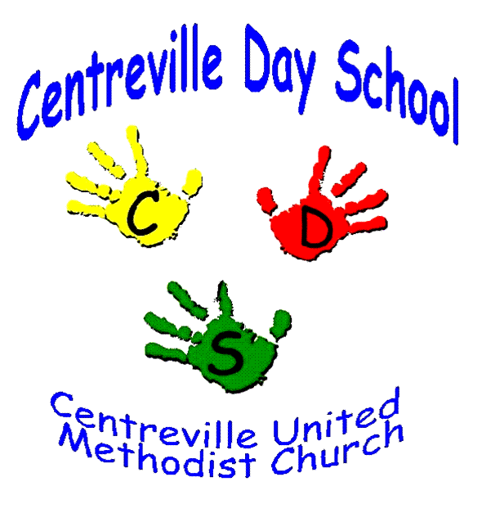
2025-2026 School Year
Preschool Priority Registration Information
CUMC Members/Current CDS Families

Centreville Day School will begin accepting priority applications for fall admission beginning January 10 – January 17. During this time completed application and registration fees will be collected during our morning carpool. Please place the application and registration fee check in a sealed envelope with your child’s name on the front and hand to the CDS Staff member unloading your child, not in their tote bag.

Please take advantage of this Priority Registration Time as classes fill up quickly!

To register your child for the 2025-2026 school year, complete the following steps:

- Complete the Application for Admission (both sides). Choose up to 2 classes (if possible). Rank them 1-2 in order of your class preference. Make sure your child is the correct age for the class you wish to enroll in (we follow FCPS age requirements). We will not make any exceptions to the age requirements. You may refer to the application for age requirements.
- Payment: Please pay by check your non-refundable registration fee of $125 ($100 for CUMC members). Make the checks payable to CDS. We cannot accept cash. Each child will be placed in a class based on the preference indicated on the Centreville Day School Application. If the class is full, we will look at the second preference indicated and place your child on the wait list for your first choice. We will do the same for each preference indicated. You will be receiving an invoice through your parent portal in FAMLY for your one-month advance tuition payment June 1st.

Once all applications have been processed, you will receive notification of class placement. Your payment must be paid within 5 days (of June 1) to maintain your child’s placement in the classroom. This advance payment will be applied to your child’s May 2025 tuition. No refunds will be given after July 1, 2025.
General Public registration will begin on January 21, 2025. We will accept applications on a first come, first served basis.
Centreville Day School welcomes all children regardless of race, religion, or nationality.

Centreville Day School reserves the right to remove any child from its roster if the information on the Application for Admission is found to be untrue or incomplete.

*All Children must be adequately immunized to enter our preschool program.
(No exemptions accepted)

Centreville Day School
dayschool@centreville-umc.org
571-522-1875
6400 Old Centreville Road
Centreville, VA 20121
www.centreville-umc.org
www.facebook.com/CDSPreschool

