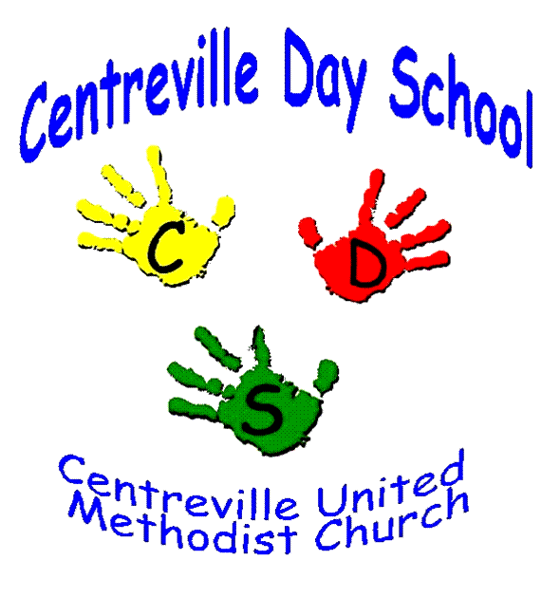
2025-2026 School Year
Preschool Registration Information for New CDS Families

Centreville Day School will begin accepting applications for fall admission beginning January 21th. During this time completed applications and registration fees will be accepted. Please place the application and registration fee check in a sealed envelope with your child’s name on the front and bring it to the CDS Office M-F between 1:00-3:00. Please use the preschool entrance located on the side of the church building and ring the bell for assistance. If you choose to mail your application and check, please send it to the address below. Just remember the classes will be filled on a first come first served basis.

To register your child for the 2025-2026 school year, the following steps must be completed:

- Complete the Application for Admission (both sides). Choose up to 2 classes (if possible). Rank them 1-2 in order of your class preference. Make sure your child is the correct age for the class you wish to enroll in (we follow FCPS age requirements). We will not make any exceptions to the age requirements. You may refer to the application for age requirements.
- Payment: Please pay a non-refundable registration fee of $125 ($100 for CUMC church members) and your one-month advance tuition (which will be applied to your May 2026 tuition) by check. Make the check payable to CDS. We cannot accept cash. Each child will be placed in a class based on the preference indicated on the Centreville Day School Application. If the class is full, we will look at the second preference indicated and place your child on the wait list for your first choice. We will do the same for each preference indicated. No refunds will be given after July 1, 2025.
- Once all applications have been processed, you will receive notification of class placement and a link to sign up for “FAMLY” which is our online service for all future payments. Once you fill out the registration on “FAMLY” you will be invited to set up your Parent Portal where all future payments will be made.

We will accept applications on a first come, first served basis until classes are filled.

Centreville Day School welcomes all children regardless of race, religion, or nationality.

Centreville Day School reserves the right to remove any child from its roster if the information on the Application for Admission is found to be untrue or incomplete.

*All children must be adequately immunized to enter the preschool Program*
(We do not accept any Exemptions)
Centreville Day School
dayschool@centreville-umc.org
571-522-1875
6400 Old Centreville Road
Centreville, VA 20121
www.centreville-umc.org
www.facebook.com/CDSPreschool

