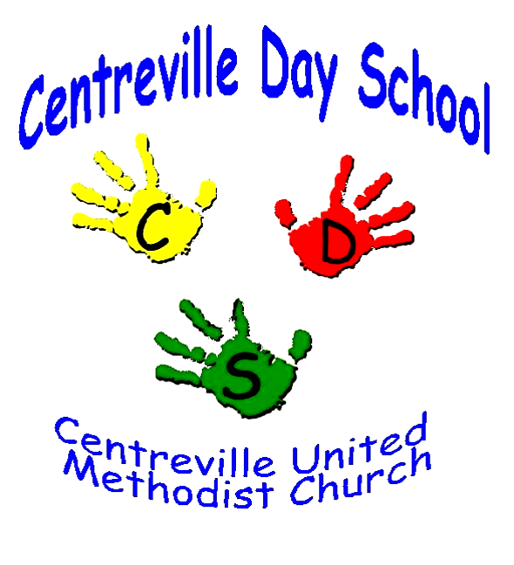

2025-2026 CDS School Calendar

August 27 | Parent Orientation @ 6:00 – 8:00 PM (Sanctuary)
August 28 | Children’s Classroom Orientation (in Classrooms with parents)
September 2 | Classes Begin-Abbreviated Schedule ( all week long)  9:00 AM - 11:00 AM
September 8 | Regular Schedule Begins and Lunch Bunch Begins  9:00 AM - 12:00 PM
September 23 | Student Holiday
October 2 | Student Holiday
October 13 | Indigenous People Day-School Holiday
October 20 | Student Holiday
October 30 | Halloween Parade @ 11:30
November 3-4 | Parent-Teacher Conferences – Preschool Closed (Teacher planning)
November 11 | Student Holiday
November 20 | Thanksgiving Feasts (ROC) 3’s and 4’s classes (for students)
November 26-28 | Student Holiday– Preschool Closed (Thanksgiving)
December 17 | Christmas Program-3’sand 4’s classes @11:00AM (Sanctuary)
December 22-January 2 | Christmas/New Year’s Break– Preschool Closed
January 8 | Kindergarten Readiness 7:00 PM (parents and guardians)
January 8-14 | Priority Registration Fall 2026-2027 (Currently Enrolled Families)
January 19 | Martin Luther King Day– Preschool Closed
January 29-30 | Student Holiday
February 16 | Presidents Day- Preschool Closed
February 17 | Teacher Work Day
March 20 | Student Holiday
March 30-April 6 | Spring Break/Easter Monday
April 10 | Student Holiday
May 5 | Art Show 12:15-1:15 (no lunch Bunch)
May 20 | PreK 4’s Graduation 10:30am (Sanctuary)
May 22 | Last Day of Classes (No lunch Bunch)

Inclement Weather Policy:
Centreville Day School follows Fairfax County Public School (FCPS) decisions for school closings due to inclement weather. These school closing decisions are available online at fcps.edu. To receive closing announcements from FCPS, send a text message to 67587 with the word “SUBSCRIBE”.

1) If FCPS is closed, CDS will also be closed. 2) If FCPS opens 1 or 2 hours late, CDS will open from 10:00-12:00. 3) If FCPS closes early, please pick up children from school immediately. If a decision is made to close the CUMC Building due to dangerous conditions and FCPS is open, we will communicate this information as soon as possible via email. Days missed due to inclement weather and emergency closings will not be made up.

dayschool@centreville-umc.org Preschool Office: 571-522-1875 Church Office: 703-830-2684

